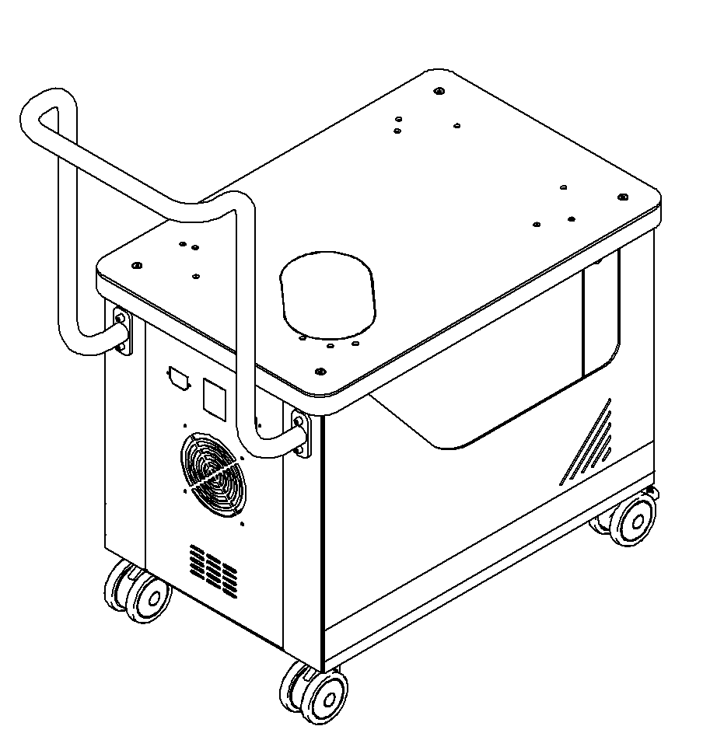
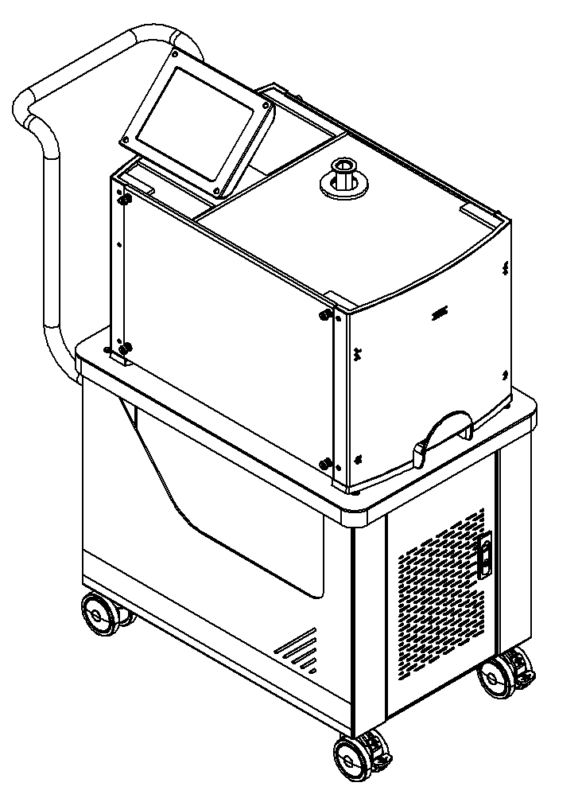
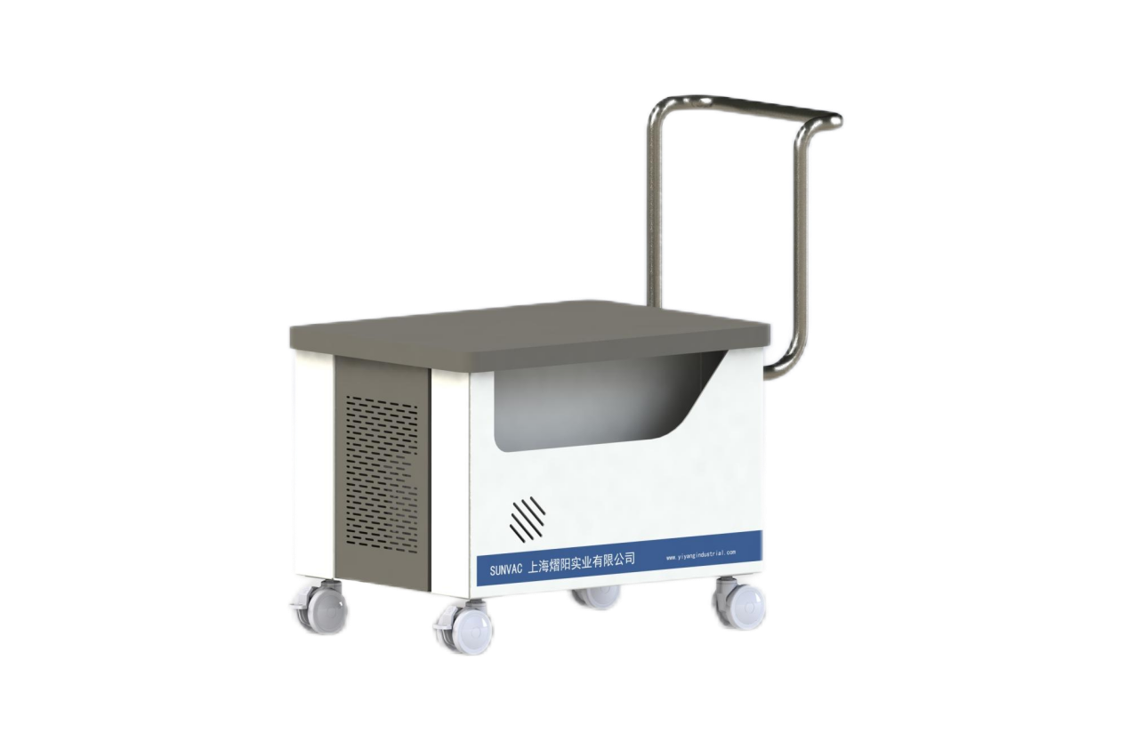

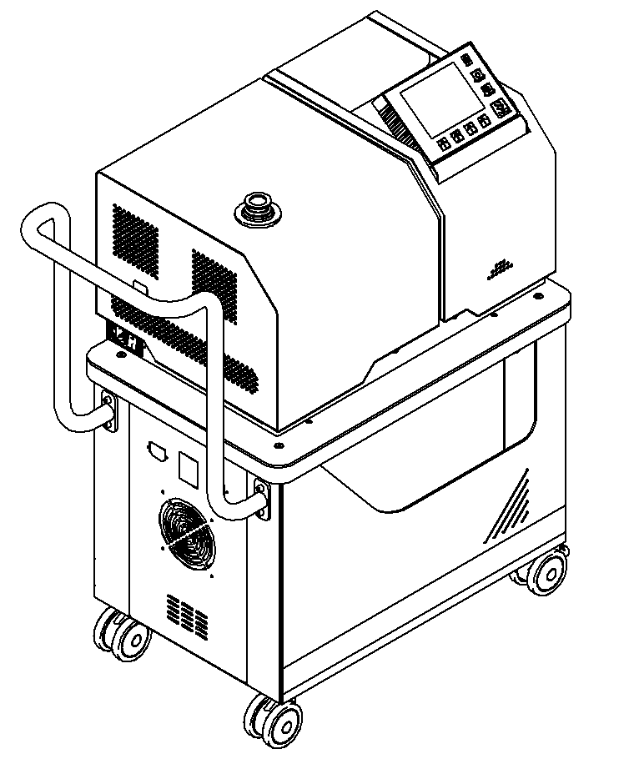

Leak Detector Trolley User Manual

Date of revision：2024.11

上海熠阳实业有限公司
www.yiyangindustrial.com

Table of contents
Introduction 1
Appearance Dimensions 1
Parts Desription 2
Assembly Instructions 2
Accessories 4
Transport Instructions 4

Introduction
The trolley is a special trolley for double-layer movable leak detector, the upper layer is placed with a leak detector, the lower layer is placed with a vacuum pump, and there is a certain storage space at the bottom. The bottom silent universal wheels can be moved flexibly, and the brake latch can smoothly fix the trolley to the desired place. Reserved electrical wiring ports allow for easy expansion of power supplies and cooling fans. Strong load capacity, can load 200Kg.

Specifications
Model and specifications | PTC-Ⅰ | Remark
Applicable Leak Detector | Agilent PD03, Pfeiffer ASM340, YIYANG SV280, etc
Applicable Vacuum Pump | DRV-16, DRV-24, ISP-500C , etc
Material | Q235
Weight | 36Kg | curb weight
Incoming Power Supply | AC220V | reserved electrical interface

Note: Some machines need to be equipped with holes by the user.

Appearance Dimensions
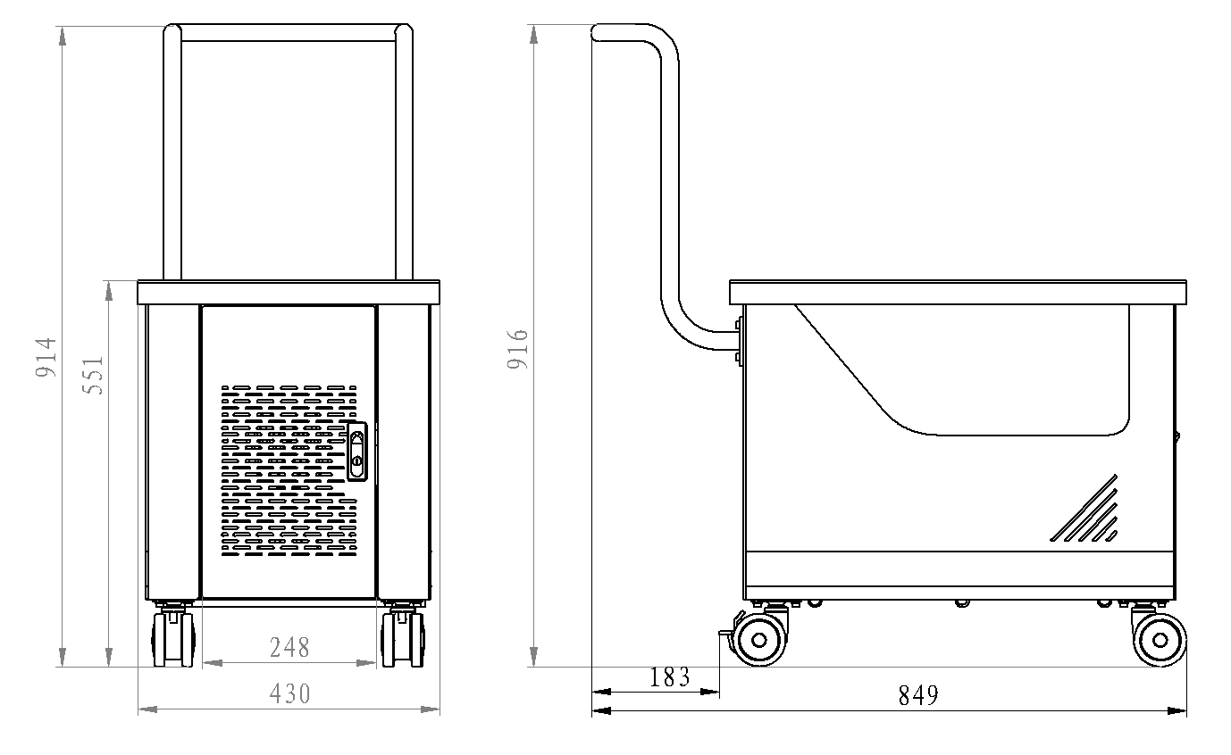
Note: The size unit is "mm"

Part Description
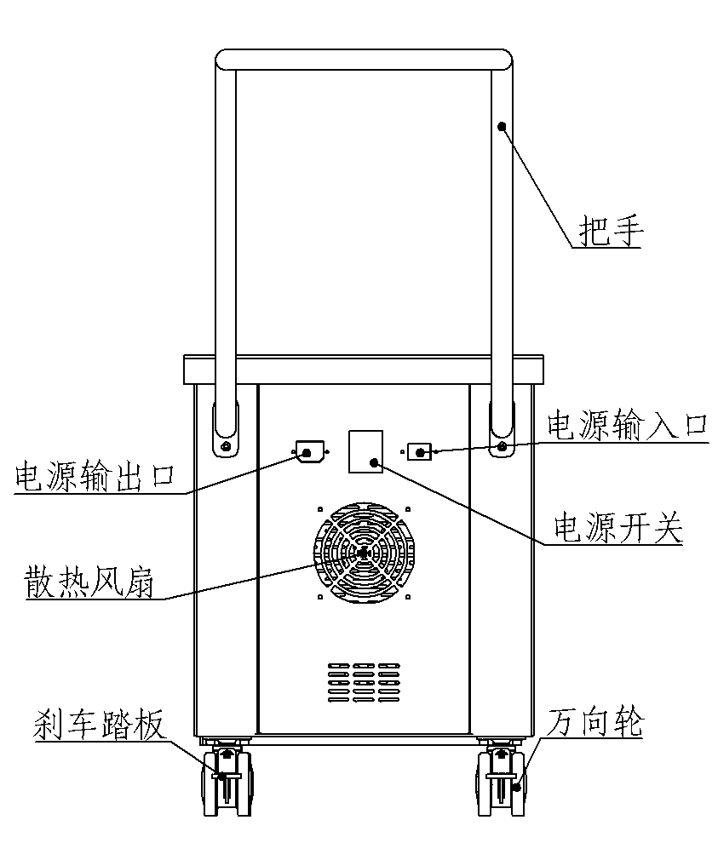
Handle
Power input port
Power Switch
Universal Wheel
Brake pedal
Cooling Fan
Power Output Port

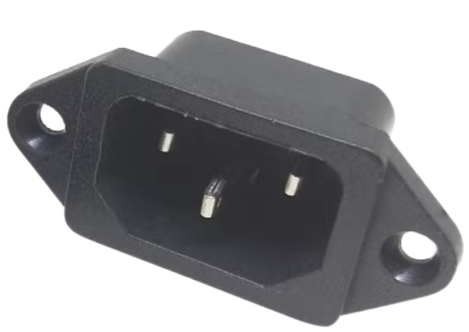
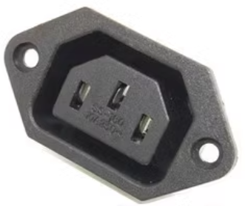

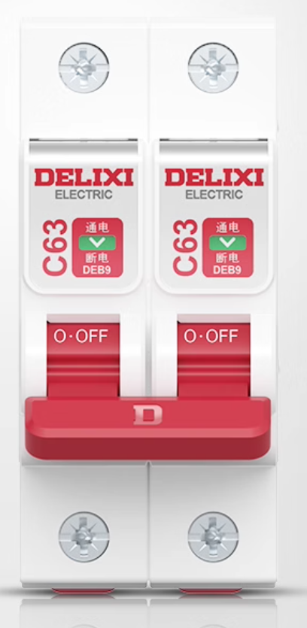
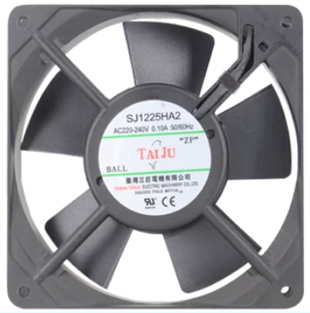

Note: All electrical accessories must be selected by the user according to application requirements. Specific specifications and parameters are provided in the attachment.

Assembly Instructions
Refer to the diagram below for the disassembly and assembly steps of each trolley component. For example, if installing a larger-sized scroll pump, remove component number 3.
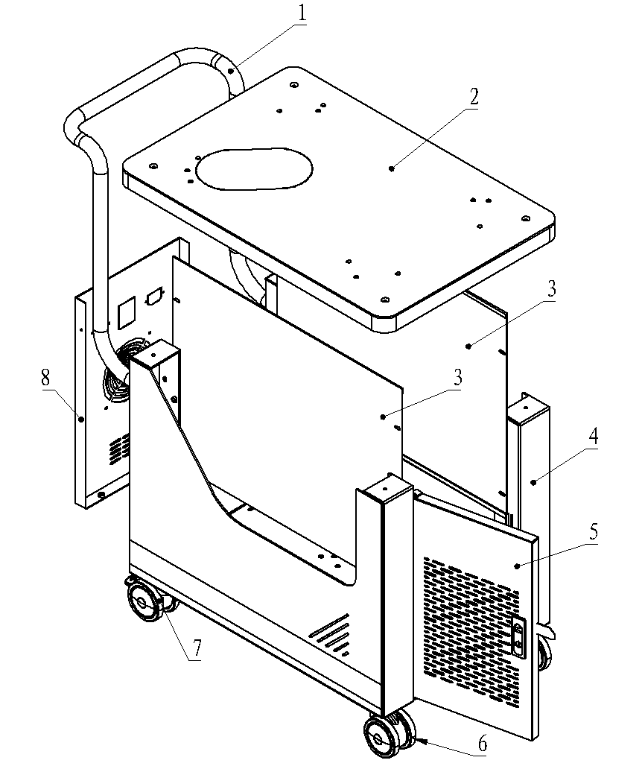
Tools：
hexagon-shaped allen wrench 3mm
hexagon-shaped allen wrench 4mm

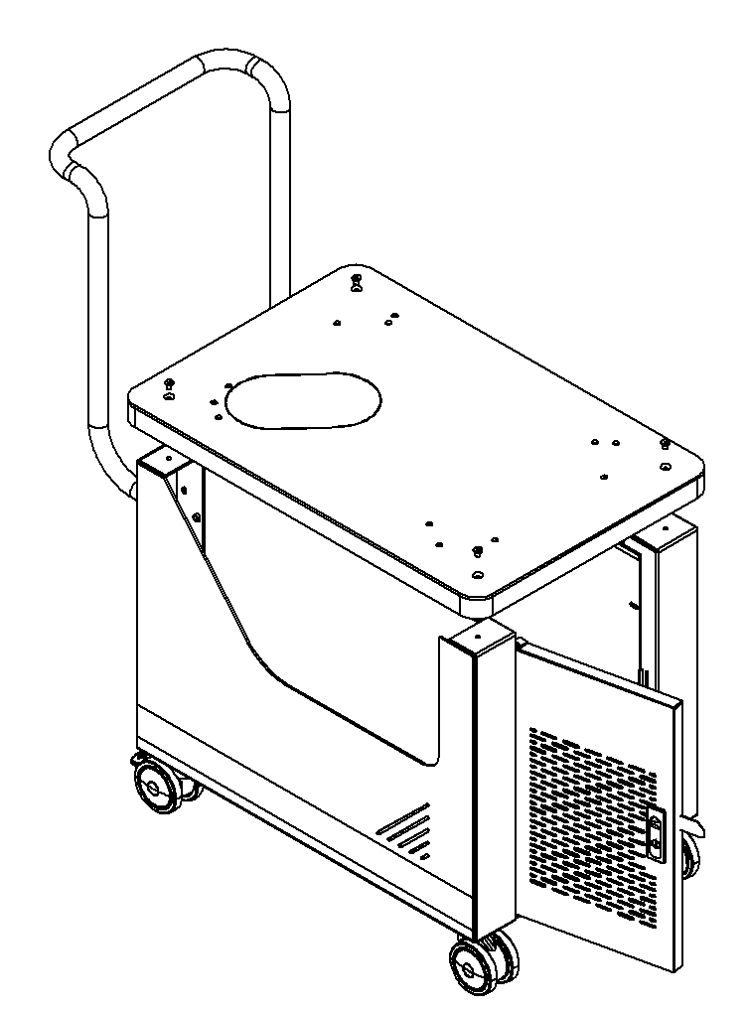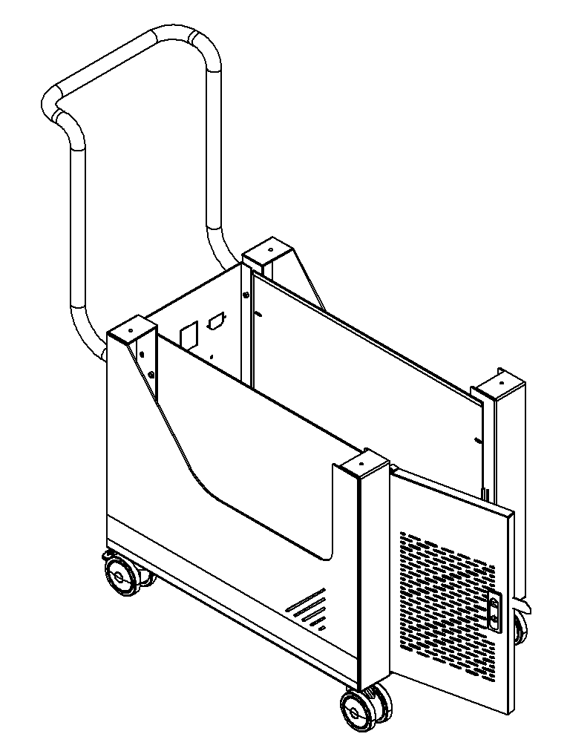
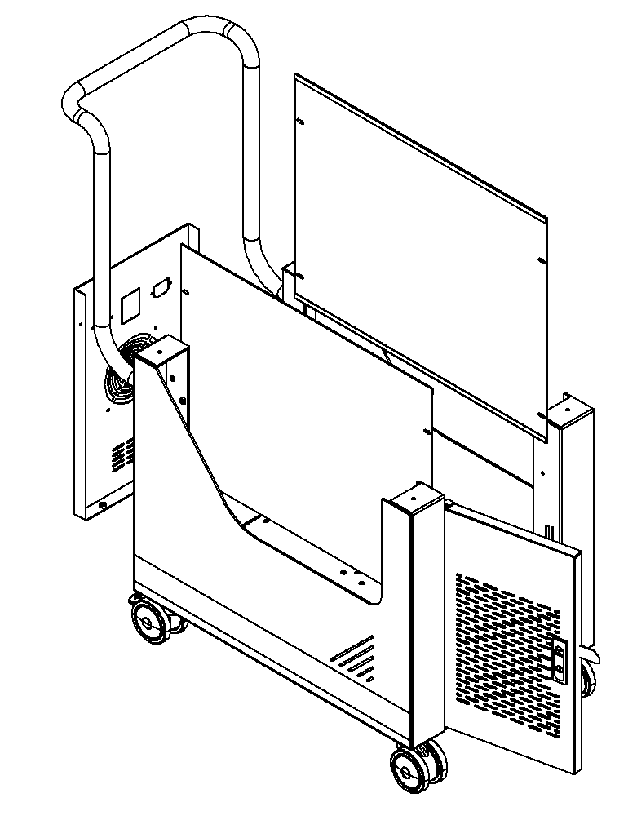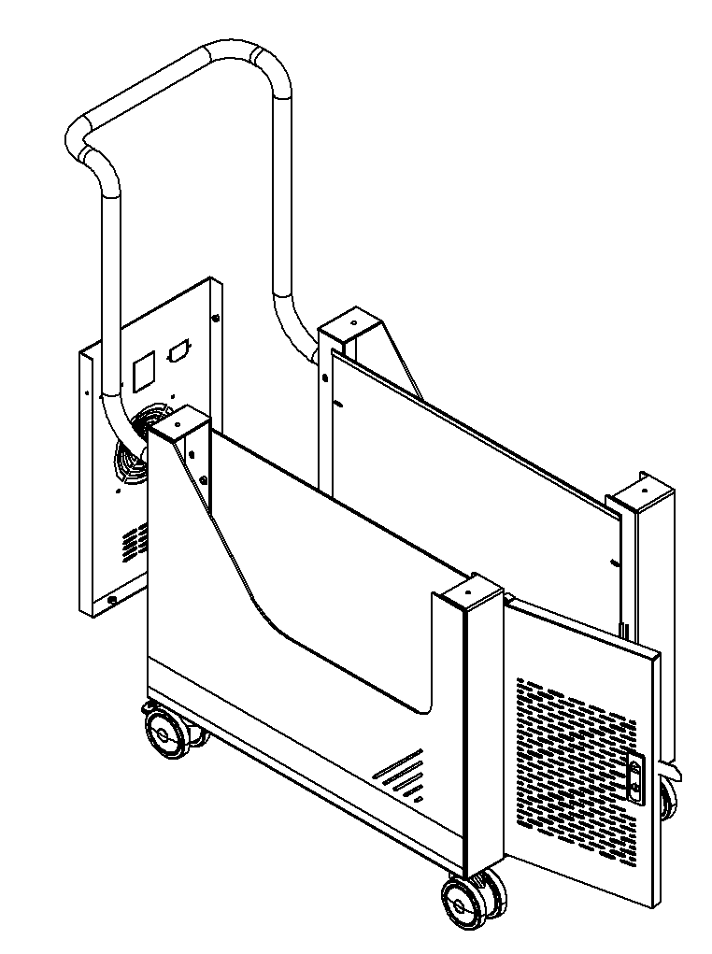

Machine Components
No | Description | Specification | Quantity | Remark
1 | Power Input Outlet | AC-03/220v | 1 piece
2 | Power Output Outlet | AC-06/220v | 1 piece
3 | Air Circuit Breaker | 2P/10A /220v | 1 piece
4 | air circuit breaker mounting clip | DZ47-2P | 1set
5 | Cooling Fan | 12025/220v | 1 set

Transportation Instructions
Two people should cooperate to lift the trolley and remove it from the transport pallet.
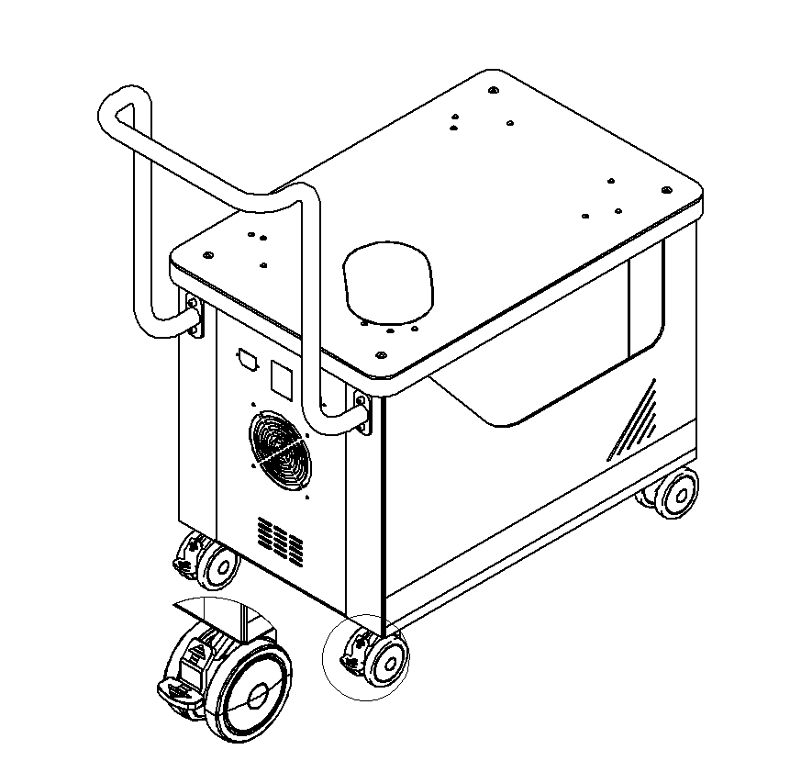
It is strictly forbidden to drag in this direction or in the opposite direction, otherwise it will cause damage to the universal wheel.
Pressing the clip down engages the brake lock, while lifting it releases the lock. The clip must be lifted when moving.

Shanghai Yiyang Industrial Co., Ltd.
- 7*24 hours remote technical support
- Phone Number：86+21 5811 0838 86+186211379836
- Website：www.yiyangindustrial.com
- Address：Room 302, Building 1, Shuo Gu Kechuang Center, No. 638 Jianyun Road, Pudong New District, Shanghai, China

